Team Meeting Minutes & Status Update

# **Meeting #3**

Date: 09/09/2019

**Participants:**

* Dr Kevin Lee, supervisor, client
* Greg McIntyre
* <>

**Agenda:**

* <>

**Action Items from Last Meeting (DD/MM/YYYY):**

* Create an Arduino concept passing data to web service, Greg, 02/09/2019
* Create an initial GUI version, Bronte, 02/09/2019
* Create simple backend receiving from web service, Sean and Greg, 02/09/2019 – Sean: successfully completed
* Have a simple working prototype, TEAM, 02/09/2019

**Minutes:**

* **<>**

**Decisions:**

* <>

**Action Items:**

* Extend backend to handle data from Arduino devices, Sean, 16/09/2019

# **Previous Meeting Minutes**

# **Meeting #2**

Date: 02/09/2019

**Participants:**

* Dr Kevin Lee, supervisor, client
* Greg McIntyre

**Agenda:**

* API aims
* Device interaction
* MQTT aims
* GUI development
* Architecture development
* Documentation

**Action Items from Last Meeting (DD/MM/YYYY):**

* Develop knowledge to achieve, MQTT communication (pub/sub) using react.js and Arduino, Greg, complete.
* Work on Project proposal documentation, All, Complete.

**Minutes:**

* API aims, the API should be designed to be able to be passed to and from many different varying devices, MQTT via a webserver would allow for more efficient, IoT communication.

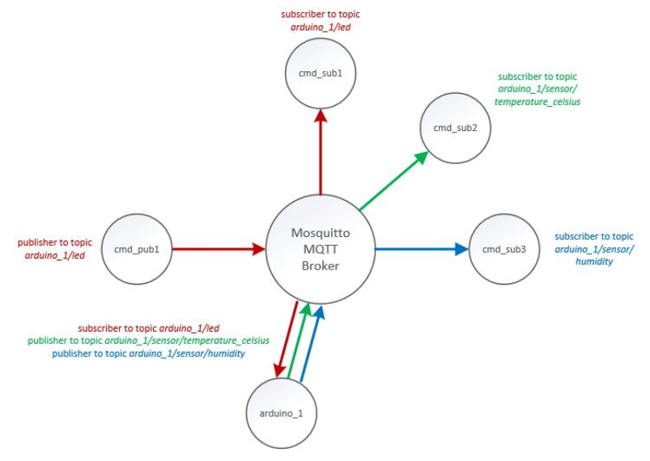

* Device interaction, we want to be able to use varying devices to pass the API data, using a raw, JSON format would be most efficient as we could make many devices (Arduino, Raspberry PI, other) pass this data and then all the IoT capable devices could communicate effectively

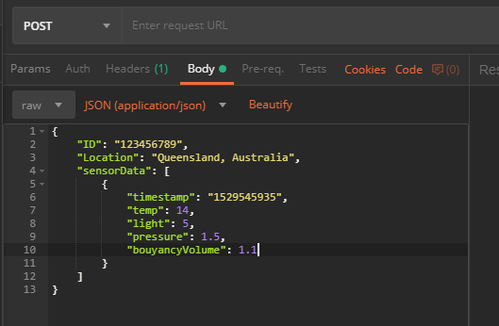

* MQTT aims

We are aiming to use MQTT sue to its versatility, currently we do not have a working system, more time investment is required

* GUI development

Possible directions, AngularJS/react to create responsiveness, sms based alerts, managed by geographical location, Device Type needs to be added, MongoDB for pulling all device data planned for future

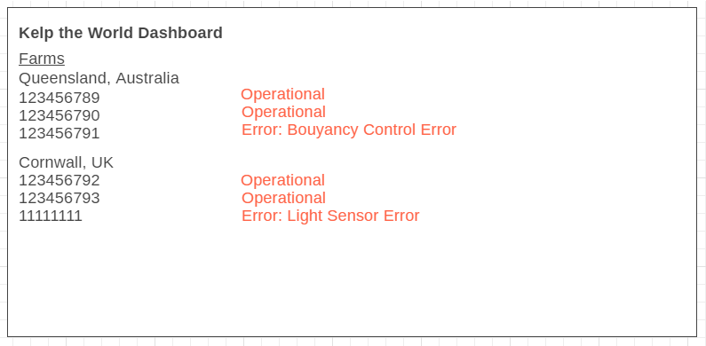

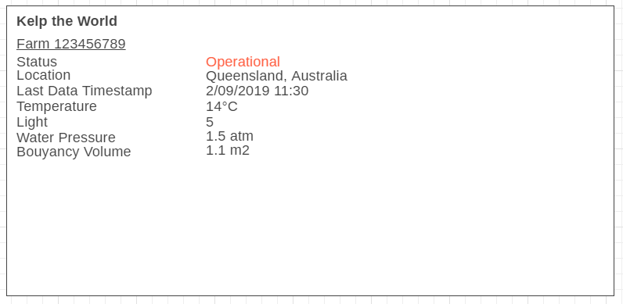

* Architecture development, Documentation

Need to begin documentation, needs to be usable for client and handover (and for the submission of the task)

**Decisions:**

* nil

**Action Items:**

* Create an Arduino concept passing data to web service, Greg, 9/02/2019
* Create an initial GUI version, Bronte, 9/02/2019
* Create simple backend receiving from web service, Sean and Greg, 9/02/2019
* Have a simple working prototype, TEAM, 9/02/2019

Sprint Increment Report

**Client/Sponsor:**

**Academic Supervisor:**

**Team:** *Kelp the World*

**Team Members:**

* Bronte Jurgens
* Greg McIntyre
* Sean Pain

Dear *Dr Lee,*

We look forward to reporting the progress of this sprint. We have captured the following points to update you on how things are going and if we have encountered any hurdles in our execution.

This recent sprint focused on researching current technologies for the best implementation of this prototype and the coming sprint will focus on *development.*

**Outcome(s) of this Sprint:**

* <>

**Activities this Sprint:**

* <>

**Activities that will occur next Sprint:**

* <>

**Proposed amendments to Scope:**

* <>

Please let us know if you have any questions.

Sincerely,

*Kelp the World*

Sprint Retrospective

**Things the team will START doing:**

* **<>**

**Things the team will CONTINUE doing:**

* Communication, documentation of progress
* Development or project, making and pushing to GitHub
* Recording of work, including hourly status updates of progress
* Prepare weekly meeting documentation earlier to make meetings more efficient
* <>

**Things the team will STOP doing:**

* <>